**ABSTRACT**

The following report is about to analyze diverse charts, graphs, and tables existing in the Medicare Annual report 2010-11. Moreover, evaluate to those charts and tables by the defined Evaluation criteria.

**INTRODUCTION**

This report consists of two parts.

**Part A – Defining Evaluation criteria**

Part A describes the common and data definite criteria which are required for creating a different type of chart, graphs, and tables used for the representation of data so the reader can understand quickly.

**Part B – Report Evaluation**

Part B evaluates Medicare annual report 2010-2011 based on the criteria which are mentioned in the report’s Part A.

This document analyses Medicare Australia ‘s annual report’s charts, graphs and tables according to the evaluating criteria mentioned in Part A to analyze the quality of creative and visualization techniques.

**PART A (Defining Evaluation Criteria)**

1. **Evaluation Criteria**

Here C is used to define the criteria.

**1.1 Common evaluation criteria for charts, graphs, and tables**

The following are common criteria for all graphical representation of annual report.

**C1:** The heading/title of figures should be simple and informative. The axis of graphs and chart and row and column of the table should have labeled properly so that the reader can understand easily with one look into the text of graphical representation so the charts, graphs, and tables should become self-explanatory.

**C2:** The starting point of x-axis and y-axis should be taken Zero.

**C3:** It is feasible to sketch a 2-D graphical representation to generate accuracy in data representation instead of 3-D figures. Even though there is several open source software for 3-D illustrations like Auto-Cad, the viewing angle of the figures could mislead to the reader for analyzing the data.

**C4:** Different colors should be used instead of using a single color to showcase the different categories or variables. These different colors help better in identifying, comparing and contrasting the categories.

**C5**: it is advisable that data should present an effective and simple manner that it helps the followers to compare data side-by-side.

**C6**: It is noticeable that time period always runs from left to right in timeline charts.

**1.2 Evaluation criteria for Bar Charts**

The bar charts are designed to display the quantity of categorical/qualitative data, and its showcases and compare the number, frequency or other measures across the diverse components of data.

**C7:** Bar chart should not be used for presenting a negative set of data. For displaying, more than seven sectors but no more than fifteen sectors, a bar graph is used.

**C8:** Bars should be drawn with a gap. Otherwise, it looks like a histogram.

**C9:** The width of the bars between them is taken consistently in a bar graph as well as to make a bar convenient for a reader to understand Y-axis should start from value zero.

**C10.** The bar chart has X-axis and Y-axis; a division on one axis and continuous value on the other value.

**1.3 Evaluation criteria for Pie charts**

The pie chart is used for presenting a quick look at the overall impression of the dataset without going to details.

**C11:** The total of the sector should always equal to 100%, as it compares the sectors against the total value.

**C12:** Data with negative values cannot be displayed in Pie chart.

**C13:** it should be considered that for more interpretable visualization of data, the pie chart should be used when a data is limited to four to five sections.

**C14:** clockwise or anti-clockwise direction should be used to display the categories as well as to ease the analysis the data can be shown in ascending or may be descending.

**1.4 Evaluation criteria for line graphs**

The line chart is used to represent and track changes over time (short time period or long time period) in graphical.

**C15:** In the line graph, the independent data and dependent data should be represented on the horizontal x-axis the vertical y-axis respectively.

**C16:** The line graph should not be used to display more than six lines. Otherwise, it becomes tough for a quick analysis of the graph.

**C17:** A line chart presents the data as a series of points connected by a straight line.

**1.5 Evaluation criteria for tables:**

Tables are representation where data is in columns and rows that organize and position data.

**C18:** The column heads of the table should be descriptive which specify and describe the nature of the existing data.

**C19:** In the table, the quantitative information should be given in a table instead of trends.

**C20:** There should be enough space columns, and rows in the table and vertical and horizontal lines are used to segregating the data

**C21:** In terms of variables and data, the table should be represented manner sensibly. The best method is to display variables of data in columns and numerical data in rows.

**C22:** The reader to analyze the table quickly, a showcase of data should be in increasing or decreasing order

**PART B(Report Evaluation)**

**Analysis 1:**

The above Line Chart depicts the information about the percentage of patient claims based on services from June 2009 to June 2011.

a). The time period of the graph runs from lefts to right. (C6)

b). Only five lines are used to represent the data which depict the different lodgment types, making it clear and non-clumsy. (C16)

c). The five different lodgment types are denoted with five different colors which makes it easy and understand and to differentiate from other lines. (C4)

d). The starting point of Y-axis is marked as Zero. (C2)

e). In the line chart, the axis is well labeled so readers can understand quickly. (C1)

**Analysis 2:**

The above bar chart lines show the number of practices using Medicare Online, Medicare Easyclaim and ECLIPSE increased over the time period from 2007-08 to 2010-11.

a). Time periods run from left to right in the bar graph timeline. (C6)

b). Three different colors are used to represent three different transmitting categories. (C4)

c). The main heading of the timeline bar graph is brief and understandable as well as x-axis and y-axis are adequately labeled making it easy to understand. (C1)

d). The bars are arranged in ascending order makes it convenient to compare and to establish the relationship between components for a reader. (C5)

e). The bars of the graph is drawn with the same gap(C8)

This pie chart depicts the information about percent of Medicare services by different nine payment types.

a). The sectors of the pie chart are representing in Clockwise (C14)

b). The pie chart has nine different slices which make it less interpretable visualization. (C13)

c). There does not have any negative value(C12)

d). The data is represented in decreased order helps the reader to analyze the pie chart quickly. (C5)

e). The title of the pie chart provides information about it. (C1)

**

The column bar graph and table reveal the income and expenses of Medicare Australia from 2008-09 to 2010-11.

a). This bar graph has two axis X and Y; a division on one axis and continuous value on the other axis. (C10)

b). The width and gaps between the bars are enough to read easily. (C9, C8)

c). The different color is used to describe two categories (red for expenses and gray for income). (C4)

d). The data of income is in decreasing order and expenses are increased with the spin of time in the table. (C22)

e). Descriptive column head provides a clear picture of the data, but x-axis and y-axis are not labeled (C1)

**

This above summary table depicts the comparison between two time periods 2009-10 and 2010-11 with two categories health professionals and members of the public.

a). The data is presented in row and columns whereas variables in columns and data(figures) in rows(C21)

b). The title of the table is informative enough for the overall understanding of data. (C1)

c). The total number is used to define the total of successful prosecutions which helps the reader to analyze the summary of the data. (C22)

d). Lines are used to segregating data horizontally but not vertically. (C20)

e). The first column does not have a heading. (C1)

**Analysis 6**

The above pie chart depicts the information about the percentage of accepted claims by the mechanism of injury for the year 2010-11.

a). The total percentage of accepted claims is equal to 100%. (C11)

b). in the pie chart, there is no negative value; it shows only positive values. (C12)

c). The percentage of accepted claims is clock-wise direction with descending order. (C13)

d). In this pie chart, 2D representation is used instead of 3D, because 3D generate inaccuracy in data representation(C3)

e). The different colors are used to represent the data, but colors are in the same shades which makes unclear. (C4)

**Analysis 7**

The above column bar graph reveals the comparison between three categories( Equity, Assets, and liabilities) with the time period from 2008-09 to 2010-11.

1. The graph has a clear 0 for its X-axis, so the horizontal chart follows the standard criteria of graphs. (C2)
2. The graph does not represent the negative data. (C7)
3. The data is presented in an organized manner that permits the reader to compare the information quickly. (C5)

d). the bar graph is self-explanatory, and heading is brief and informative, but the axis is not labeled properly(C1)

**Analysis 8:**

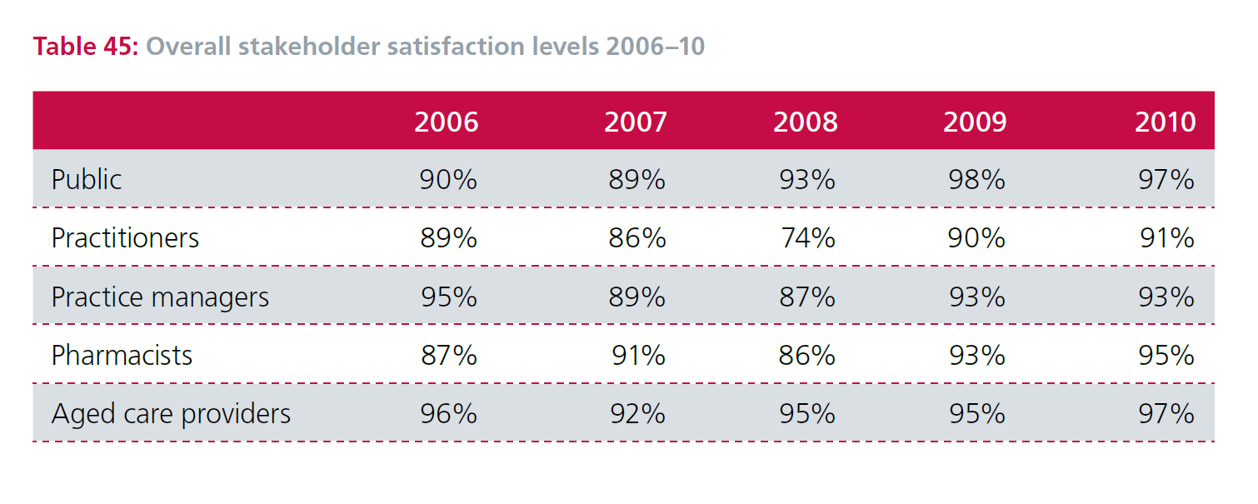

The table chart reveals information about the overall satisfaction level of stakeholder over a period of five years.

a). The table chart illustrates the data in figures means quantitative information instead of showing the trends. (C19)

b). In the table, the title of table chart depict the nature of existing data in the table, but the first column does not have headed. (C18)

c). There is a lack of presentation; different color can be used to represent the row and column heads. (C4

d). There are enough gaps between rows and columns, but it is not separated with a vertical line. (C20)

**Analysis 9**

The above column chart shows the percentage of Medicare service by claim type.

A). In the bar graph, different colors are used to show the different categories instead of one color to represent various categories/ variables. These colors make it better to identify the features of the graph. (C4)

B). The y-axis is marked well because there is a starting point zero defined. (C2)

C). There is sufficient spacing between the bars which does not make it histogram (C8)

D). The column chart consists only of positive values; no negative value has been displayed. (C7)

E). The chart is defined correctly but the time period is not mentioned. (C1)

**Analysis 10**

The given TimeLine Chart indicates the satisfaction level of stakeholders from 2002-03 to 2010-11.

a). The starting of the axis does not start from zero. (C2)

b). The time here is in years from left to right. (C6)

c). In the line chart, different colors are used to represent the data, but two same colors (gray and dark gray) makes it clumsy and tough to read. (C4, C16)

d). The independent and dependent data is displayed on Y-axis and X-axis. (C15)

e). The heading of a line graph is clear and understandable, but the axes are not appropriately labeled which makes it hard to understand. (C1)

f). The data points are bend together to form a series of a straight line (C17)

**References**

1). Humanservices.gov.au. (2019). [online] Available at: https://www.humanservices.gov.au/sites/default/files/documents/medicare-australia-annual-report-2010-11-full-report.pdf [Accessed 1 Apr. 2019].

2). Mundie, S. (2014). *Pie Chart | Better Evaluation*. [online] Betterevaluation.org. Available at: https://betterevaluation.org/en/evaluation-options/piechart [Accessed 29 Mar. 2019].

3). Betterevaluation.org. (2014). *Bar Chart | Better Evaluation*. [online] Available at: https://betterevaluation.org/en/evaluation-options/BarChart [Accessed 3 Apr. 2019].

4). Betterevaluation.org. (2014). *Line Graph | Better Evaluation*. [online] Available at: https://betterevaluation.org/en/evaluation-options/LineGraph [Accessed 3 Apr. 2019].